Geometric Figure Composition

Definition
# Source: AI Source: Provided by: [Data Path: Persons Table -> ID Column: 1, Name_En Column: Motasem Essam] -> From: [ChatGPT] on [7/25/2026]
Geometric Figure Composition is the process or arrangement of combining two or more geometric figures or geometric components to form a larger, more complex figure.
The components may include points, line segments, rays, angles, polygons, circles, arcs, and other geometric shapes. They may be joined, overlapped, connected, or arranged within one another.
Note: This is a descriptive geometric concept rather than one universally standardized mathematical classification.

Simple Definition
# Source: AI Source: Provided by: [Data Path: Persons Table -> ID Column: 1, Name_En Column: Motasem Essam] -> From: [ChatGPT] on [7/25/2026]
Geometric figure composition is the combination of multiple geometric figures to create or describe a larger geometric figure.
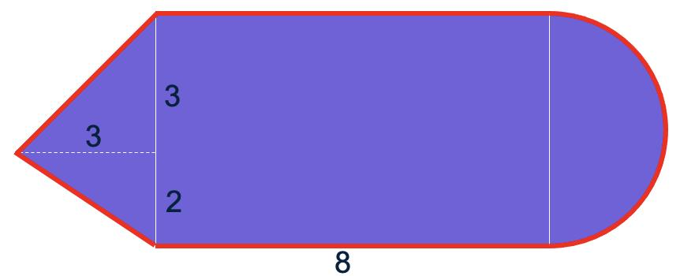

Main Classification
# Source: AI Source: Provided by: [Data Path: Persons Table -> ID Column: 1, Name_En Column: Motasem Essam] -> From: [ChatGPT] on [7/25/2026]
The following is a practical classification based on how geometric figures are combined.

1. Joined-Figure Composition
# Source: AI Source: Provided by: [Data Path: Persons Table -> ID Column: 1, Name_En Column: Motasem Essam] -> From: [ChatGPT] on [7/25/2026]
Two or more figures are joined along a side or boundary to form a larger figure.
Example: A square joined to a triangle along one side to form a house-shaped figure.
Key idea: The components share part of their boundaries.
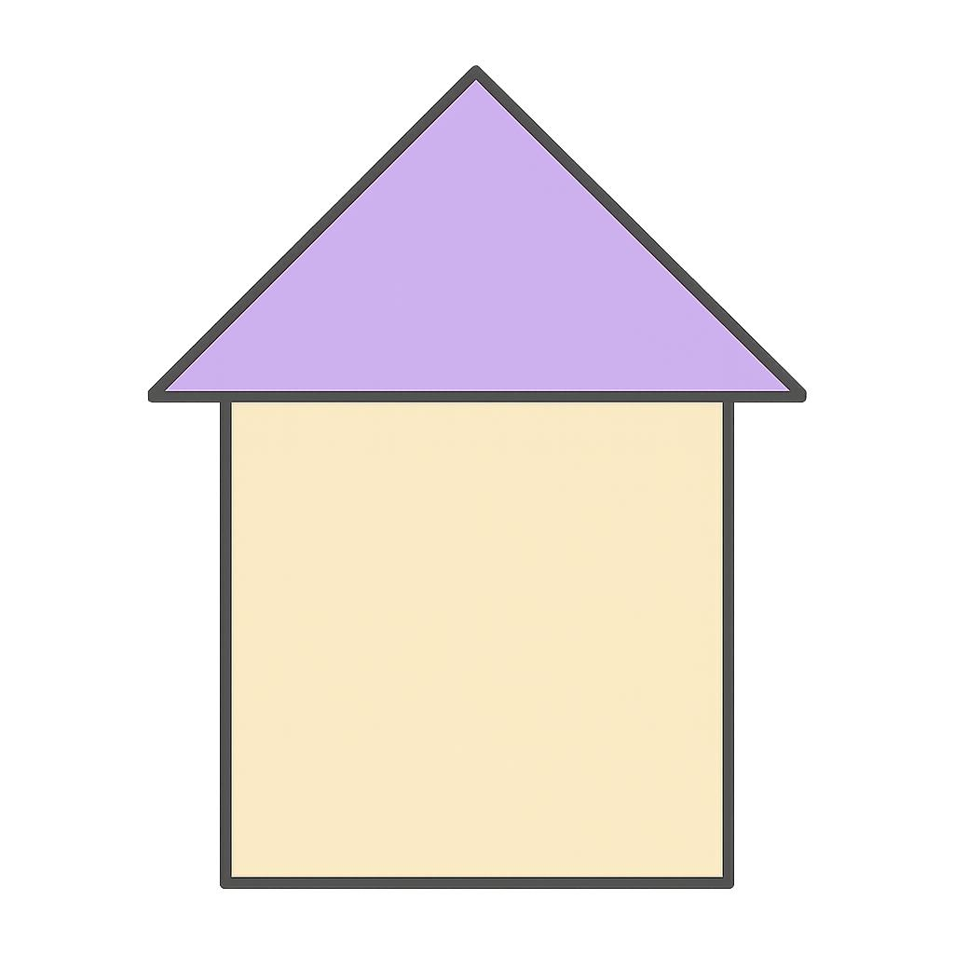

2. Overlapping-Figure Composition
# Source: AI Source: Provided by: [Data Path: Persons Table -> ID Column: 1, Name_En Column: Motasem Essam] -> From: [ChatGPT] on [7/25/2026]
Two or more figures occupy regions that overlap.
Example: Two intersecting circles or a circle overlapping a rectangle.
Key idea: The figures have a common region or intersection.
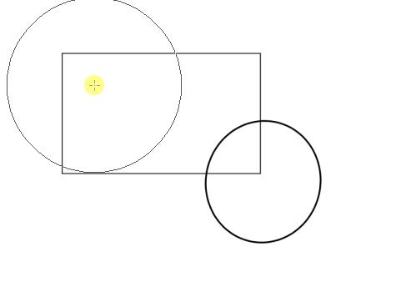

3. Adjacent-Figure Composition
# Source: AI Source: Provided by: [Data Path: Persons Table -> ID Column: 1, Name_En Column: Motasem Essam] -> From: [ChatGPT] on [7/25/2026]
Figures are positioned next to one another, usually sharing a boundary or meeting at a point.
Example: Two rectangles placed side by side to form a larger rectangle.
Key idea: The figures are connected or neighboring components.
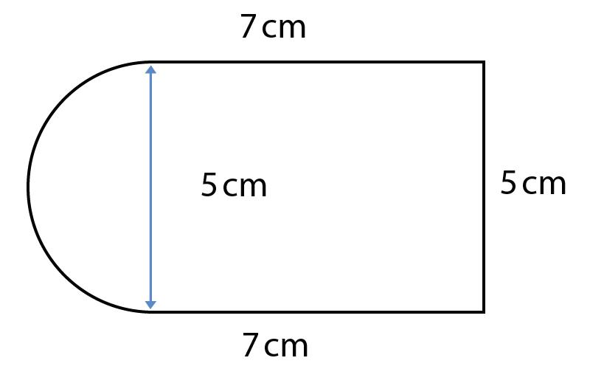

4. Nested-Figure Composition
# Source: AI Source: Provided by: [Data Path: Persons Table -> ID Column: 1, Name_En Column: Motasem Essam] -> From: [ChatGPT] on [7/25/2026]
One geometric figure is placed inside another.
Example: A circle inscribed in a square, or a triangle drawn inside a circle.
Key idea: One figure is contained within another, without necessarily sharing its boundary.
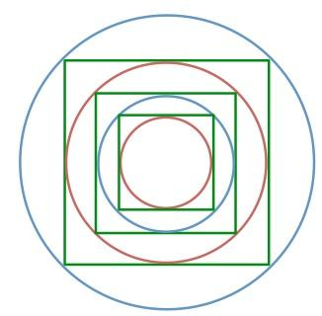

5. Mixed-Shape Composition
# Source: AI Source: Provided by: [Data Path: Persons Table -> ID Column: 1, Name_En Column: Motasem Essam] -> From: [ChatGPT] on [7/25/2026]
Different types of geometric figures are combined.
Example: A rectangle with a semicircle attached to one end and a triangle attached to another.
Key idea: The composition uses different geometric families, such as polygons and circular figures.
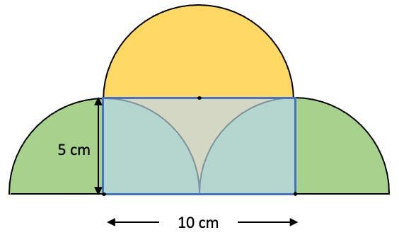

6. Partitioned-Figure Composition
# Source: AI Source: Provided by: [Data Path: Persons Table -> ID Column: 1, Name_En Column: Motasem Essam] -> From: [ChatGPT] on [7/25/2026]
A figure is divided into smaller geometric regions.
Example: A square subdivided into four smaller squares and several triangles.
Key idea: The components partition the larger figure, rather than necessarily forming it by attaching separate shapes.
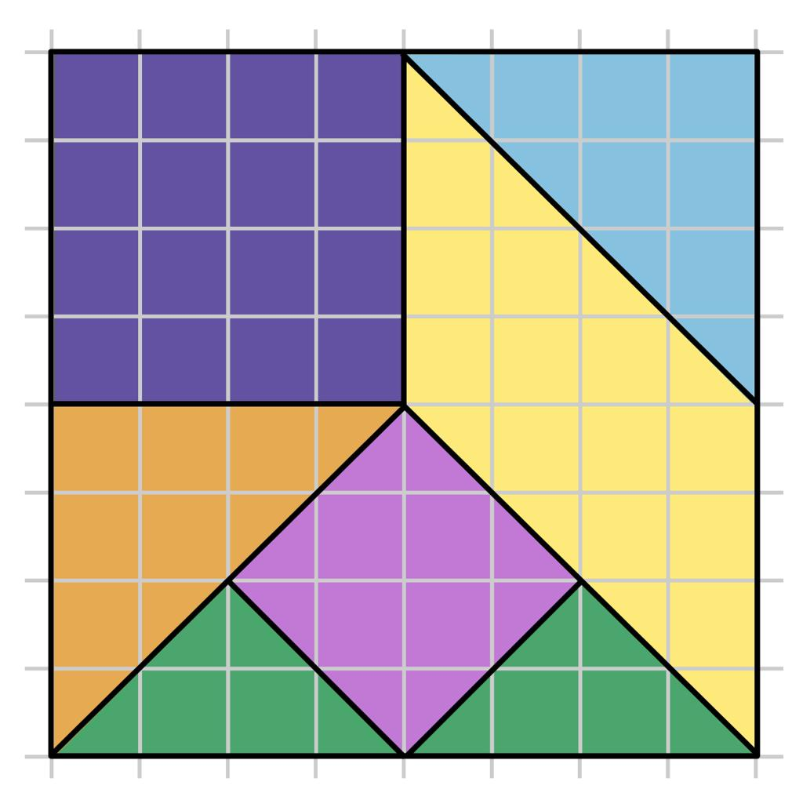

7. Boundary-Based Composition
# Source: AI Source: Provided by: [Data Path: Persons Table -> ID Column: 1, Name_En Column: Motasem Essam] -> From: [ChatGPT] on [7/25/2026]
A figure's boundary is made from multiple geometric components, such as line segments and circular arcs.
Example: A shape bounded by three straight segments and one semicircular arc.
Key idea: The composition describes how the boundary itself is assembled.
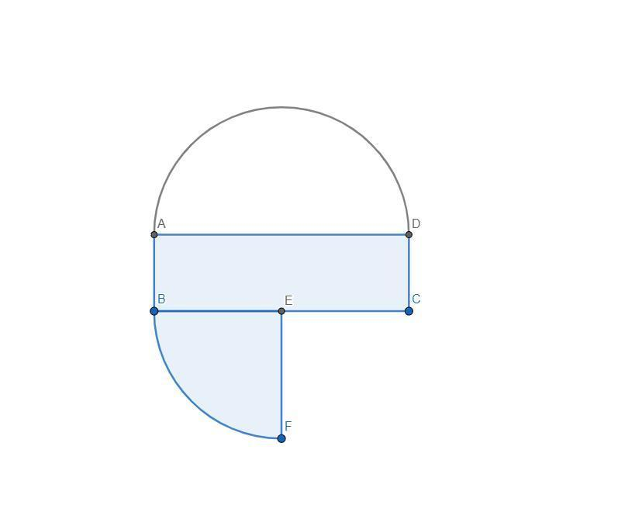

Mathematical Examples

Example 1: Rectangle and Triangle
# Source: AI Source: Provided by: [Data Path: Persons Table -> ID Column: 1, Name_En Column: Motasem Essam] -> From: [ChatGPT] on [7/25/2026]
A triangle is placed on top of a rectangle, sharing one side.
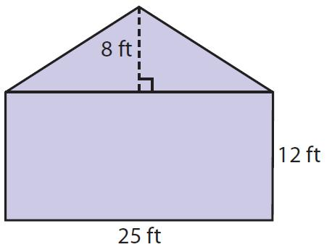
If the rectangle has width $w$and height $h$, and the triangle has base $w$and height $t$, the total area is
$$A=wh+\frac{1}{2}wt$$
This addition works because the two regions have no overlapping interior.

Example 2: Rectangle and Semicircle
# Source: AI Source: Provided by: [Data Path: Persons Table -> ID Column: 1, Name_En Column: Motasem Essam] -> From: [ChatGPT] on [7/25/2026]
A semicircle is attached to a rectangle along one of its shorter sides.
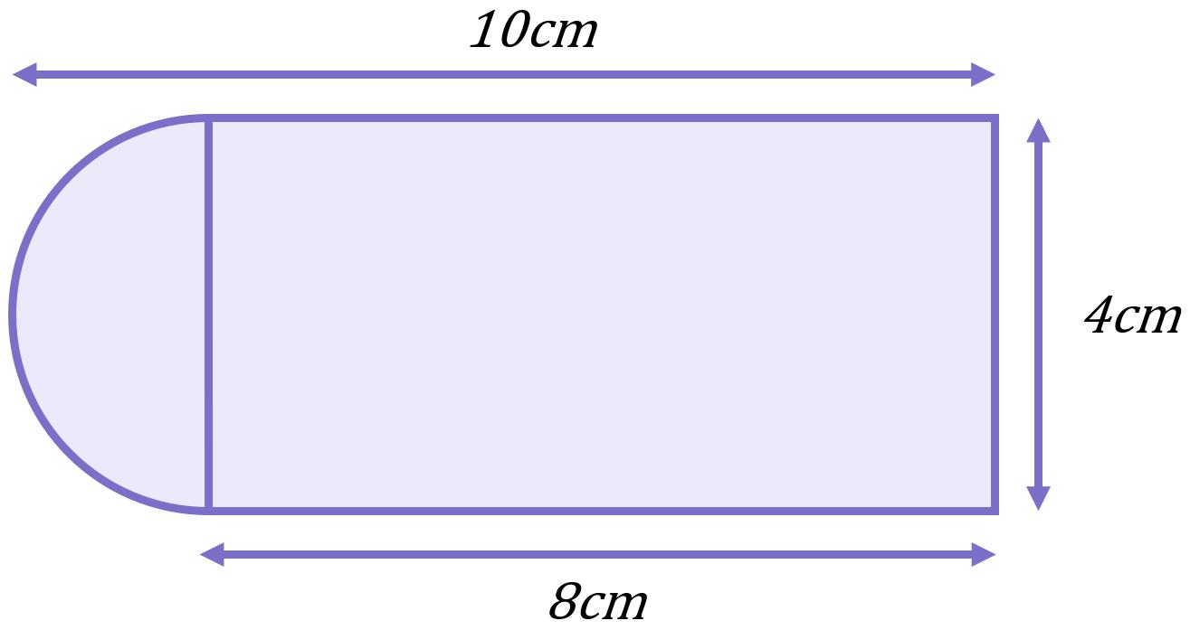
If the rectangle has length $L$, height $2r$, and the semicircle has radius $r$, then
$$A=2rL+\frac{1}{2}πr^{2}$$

Example 3: Overlapping Circles
# Source: AI Source: Provided by: [Data Path: Persons Table -> ID Column: 1, Name_En Column: Motasem Essam] -> From: [ChatGPT] on [7/25/2026]
Two circles overlap, creating a lens-shaped intersection.
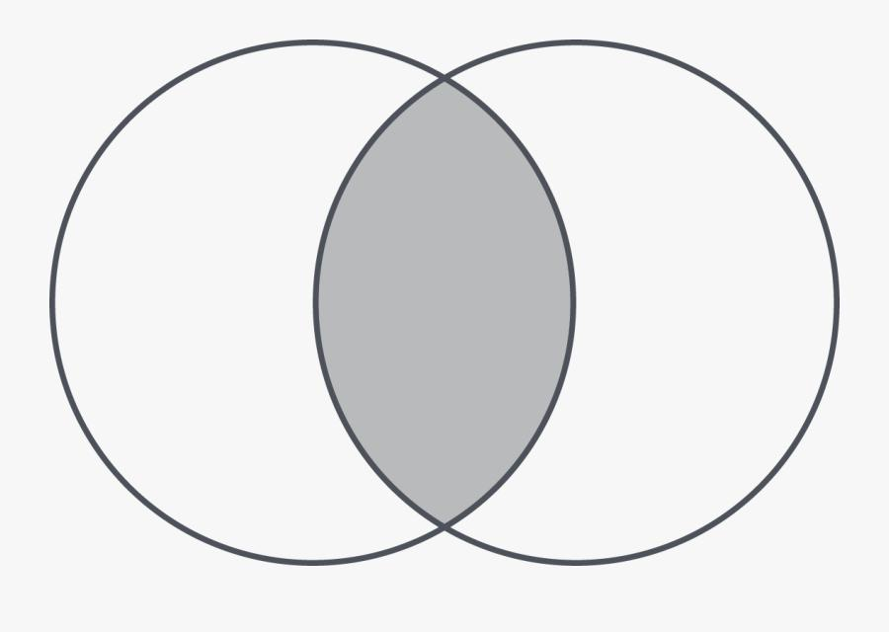
If the goal is to find the area covered by either circle, the overlap must not be counted twice:
$$A\left(A∪B\right)=A\left(A\right)+A\left(B\right)-A\left(A∩B\right)$$
Here, $A∪B$is the union of the two circular regions, and $A∩B$is their common region.

Important Relationships
# Source: AI Source: Provided by: [Data Path: Persons Table -> ID Column: 1, Name_En Column: Motasem Essam] -> From: [ChatGPT] on [7/25/2026]
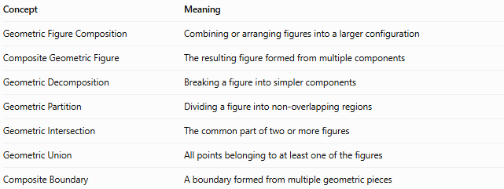
Concept | Meaning
Geometric Figure Composition | Combining or arranging figures into a larger configuration
Composite Geometric Figure | The resulting figure formed from multiple components
Geometric Decomposition | Breaking a figure into simpler components
Geometric Partition | Dividing a figure into non-overlapping regions
Geometric Intersection | The common part of two or more figures
Geometric Union | All points belonging to at least one of the figures
Composite Boundary | A boundary formed from multiple geometric pieces
Composition and decomposition are complementary processes:
$$\text{Simple Figures}⟶\text{Composition}⟶\text{Composite Figure}$$
$$\text{Composite Figure}⟶\text{Decomposition}⟶\text{Simpler Figures}$$

Classification Summary
# Source: AI Source: Provided by: [Data Path: Persons Table -> ID Column: 1, Name_En Column: Motasem Essam] -> From: [ChatGPT] on [7/25/2026]
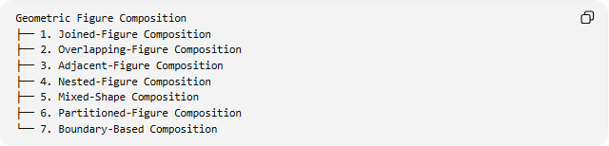
Geometric Figure Composition
├── 1. Joined-Figure Composition
├── 2. Overlapping-Figure Composition
├── 3. Adjacent-Figure Composition
├── 4. Nested-Figure Composition
├── 5. Mixed-Shape Composition
├── 6. Partitioned-Figure Composition
└── 7. Boundary-Based Composition
These categories describe different aspects of composition and are not mutually exclusive. For example, a mixed-shape composition can also be a joined-figure composition.

Key Points
# Source: AI Source: Provided by: [Data Path: Persons Table -> ID Column: 1, Name_En Column: Motasem Essam] -> From: [ChatGPT] on [7/25/2026]
- Composition combines geometric components into a larger configuration.
- Components can be identical or different shapes.
- Figures may be joined, overlap, contain one another, or partition a region.
- Area calculations depend on whether regions overlap or share only boundaries.
- The result may be a familiar standard shape or an irregular composite figure.

Conclusion
# Source: AI Source: Provided by: [Data Path: Persons Table -> ID Column: 1, Name_En Column: Motasem Essam] -> From: [ChatGPT] on [7/25/2026]
Geometric Figure Composition describes how geometric figures or components are combined or arranged to form a larger geometric configuration. It is useful in geometry, area and perimeter problems, geometric construction, diagram analysis, and computer graphics.

